
Year 8

End of Year Test
Total Marks: 45 marks
Name: ____________________________ Total Time: 50 minutes

Show working and answers on this sheet. Calculator and 1 page of A4 notes.
- (a) [1/2 each = 5]
FRACTION | DECIMAL | PERCENTAGE
$$\frac{1}{2}$$
 | 0.2
 |  | 25%
 | 1.00
$$\frac{3}{5}$$

- Simplify the ratios [1, 1, 2 = 4]
- 10 : 5 (b) 7 : 21 (c) 1m : 25cm

- Share $230 in a ratio of 1 : 3 : 6 to determine what the largest share will be. [3]

- Solve the following equations [1, 1, 2, 2, 2 = 8]
- $4+x=9$

- $3m=15$

- $6t+3-2t=24$

- $4\left(3x-2\right)=112$

- $5z-4=8-z$

- Graph the line $y=2x-1$ [2]

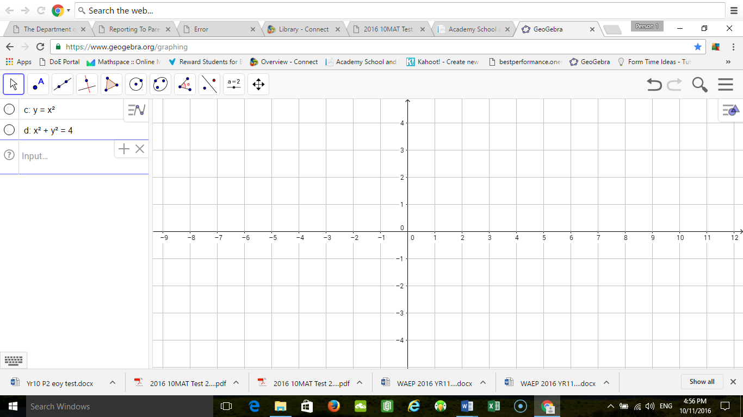

- For Jane’s 18th birthday party her parents are hiring a band. [2, 2 = 4]
The two bands to choose from are:
Drummin’ | $120 per hour
Air Guitar | $100 booking fee plus $80 per hour

Write an expression for the total cost depending on the number of hours that they play for
- Drummin’

- Air Guitar

- The following heights of have been recorded by a group of students for some seedlings they are growing in their science experiment [1, 1, 1, 2 = 5]

5cm, 4cm, 6cm, 5cm, 3m, 4.5cm

- Remembering that 1m = 100cm what is the value of the outlier: __________ cm

- Determine the mean with all entries included.

- Determine the median with all entires included.

- Given that the data set has an outlier which measure of central tendance should we use and why?

- [2, 3 = 5]
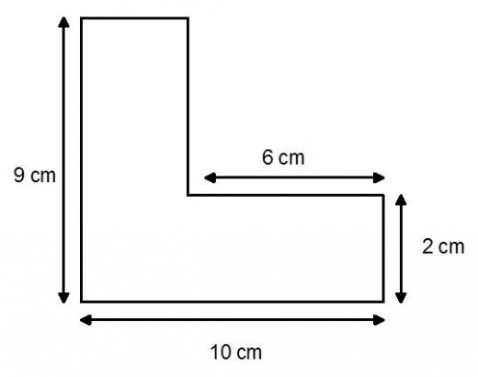
- Find the perimeter of the shape.

- Find the area of the shape in mm²

- Determine the volume of the rectangular prism below. [2]
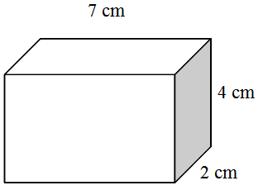

- If the area of a square is 16cm², what is the side length of the square? [1]

- If a cube has a volume of 8cm³, what is the side length? [1]

- The diagram shows a prism whose base is a trapezoid. The surface area of the trapezoidal prism is 72 cm². [3, 1, 1 =5 marks]

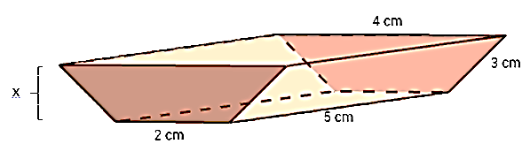

- Find the value of x.

- Find the volume of the prism.

- Determine the capacity of the prism.

END OF TEST

